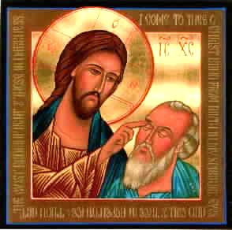
What’s Christianity Ever Done
for HEALTHCARE?
A small group study book
Ian Robinson

- A SHORT HISTORY OF MEDICINE
- PIONEERS OF FAITH AND SCIENTIFIC MEDICINE
3. LEFTOVER FROM THE DARK AGES?
4. THE ‘CHIEF GLORY’ OF CHRISTIANITY
5. CAN CHRISTIANS CONTRIBUTE WELL TODAY?

The title of this series comes from a satirical film Life of Brian, a youtube clip...
https://www.youtube.com/watch?feature=player_detailpage&v=ExWfh6sGyso#t=0

WXED is dedicated to Prof Brian Hill, who has lived, breathed, written, laboured, thought and prayed in all these ways for many decades, with not a few tears.

GOAL
- To offer essential background to the role of Christian spirituality in the history of healthcare for the community and curriculum.
- To spark a rise in the quality of discourse on the place of religion in the social capital.
- To apologise that sometimes the church corruptly accrued power in life-death matters and adopted a power of veto.
- To bring hope for a strong Christian contribution to issues facing healthcare today.

INTRODUCTION
STARTUP Q:
Do you expect that if you get sick someone will help you, no matter who you are in the social scale? You probably need to be thankful to Jesus Christ and his followers who have created that culture. It is not that way everywhere in the world.

Let’s begin by celebrating the whole scientific healthcare enterprise. These seven value statements (pictured) would summarise a lot of these strengths. DISCUSS: What do you think of these? Can you add any others?

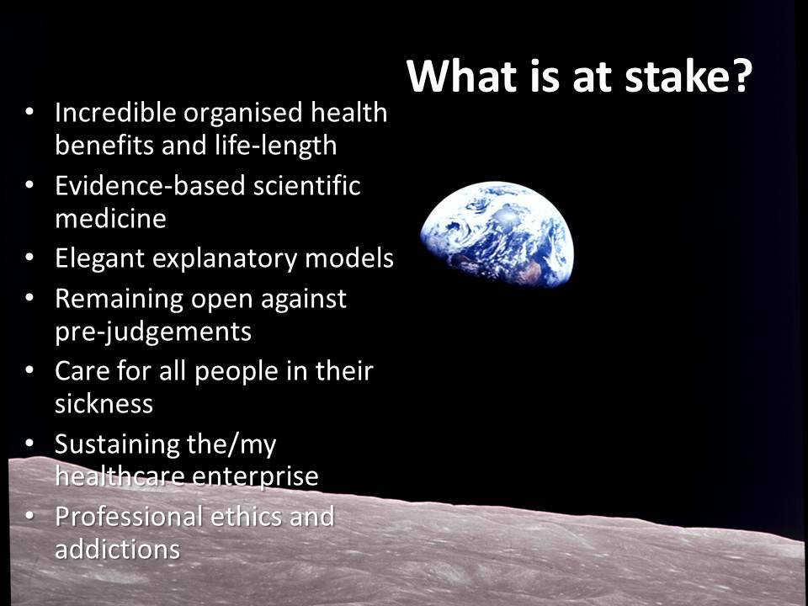
Just as this relatively recent view of earth from the moon (pictured) is a powerful testimony to human scientific ingenuity, our medical science has taken huge leaps further forwards. In addressing healthcare and its historic Christian auspices I acknowledge the faith-science debate is a part of the matter but I am reserving that for a separate topic.

STEP ONE – WHERE DID MEDICINE BEGIN?

People of faith convictions made pivotal contributions to Healthcare, founding and shaping medical science and the hospital system, in both principle and practise. This is a great story, containing lots of heroes, a record of shared learning, with widely shared benefits. We will have to skip through parts of the story. First let’s find some of the pioneers.

I will walk you through a two storey building – the house of healing.

1. At ground level, every society has walked in through the garden of herbal medicines, and some have found their way into the entry halls of basic physiological medicine (more recognisable as what we call scientific medicine) , as well as rang the doorbells of the gods. Going in further, some societies have had periods when the difficult practise of healthcare sparked into genius, the lights went on, they found rooms of diagnosis and treatments that opened new windows. These periods did not always last, for many reasons, but strangely you might notice that the new opportunities of healthcare rarely went further than the care of the military or the ruling elite, that is, the library and the formal lounge. This widespread tradition of a narrow field of care is a timely warning among today’s budget screamers.

2. There are many more rooms upstairs. To get upstairs where there are more rooms for the sick, we need to find the staircase that took people beyond this ground level practise to the much more expensive commitment of healthcare for the common good, we ned to find a different and sustained commitment. The track record will show that it is mostly people who practise their faith who have pioneered healthcare for the common good. They pioneered both the science and the system, by a sacrificial practise and principles. We are not looking for the first person to try to find healing methods: that is assumed to be universal. We are looking for earliest persons who established experimental medicine in an established facility for the general public i.e. earliest known hospital.

Presenter please note: please select the parts of this presentation that interest you. Too much to go through it all.

EARLIEST MEDICINE

As we approach the house of healing, we notice that there are rows with many plants in the garden by the front door that were planted many tens of thousands of years ago.

They are bush medicines and herbal remedies - the selective use of plants for medicine and nutrition. The ancient Chinese, Indians, Egyptians, Babylonians, and Native Americans were all herbalists. The oldest known list of medicinal herbs is c. 3000 B.C., probably a compilation of an even older Chinese oral tradition. This science is slowly gaining some recognition today.

One row comes from the ancient Greeks and Romans. Surgeons traveling with the Roman army spread their herbal expertise throughout the Roman empire, in Spain, Germany, France, and England. The greek botanist Dioscorides (d. 90CE) and Galen (131-200 A.D.), both Greek surgeons in the Roman army, compiled whole encyclopedia of herbals that remained the definitive texts for 1500 years.

Through the Middle Ages, herbalism was preserved in the monasteries of Britain and mainland Europe. Their “physick” gardens, were stocked with medicinal herbs, and served as basic training grounds. It is still practised today.

Another row of plants goes back many centuries more. Aborigines held two streams of thought. One is that serious illness and death were caused by spirits or persons practising sorcery. Even trivial ailments, or accidents such as falling from a tree, were often attributed to malevolence. That’s when they called for a clever-man versed in magic to identify the culprit. Only they could pronounce the cause of serious illness or death, and only they, by performing sacred rites, could effect a cure.

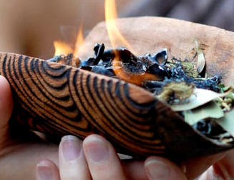
Nonetheless, Aboriginal peoples also had a regime of bush medicines. Burns, headaches, eye infections , digestive upsets, stings , injury - Aboriginal people used a range of remedies – wild herbs, animal products, steam baths, clay pits, charcoal and mud, massages, alongside string amulets and secret chants and ceremonies.

Some of these remedies had no empirical basis, but only worked due to a high placebo effect. Many remedies worked well, we can now confirm. Aromatic herbs, tannin-rich inner barks have well documented therapeutic effects. Much has been lost through colonisation. In recent years there have been attempts to record and test some of the medicinal uses– e.g. Aboriginal Pharmacopoeia in the Northern Territory.

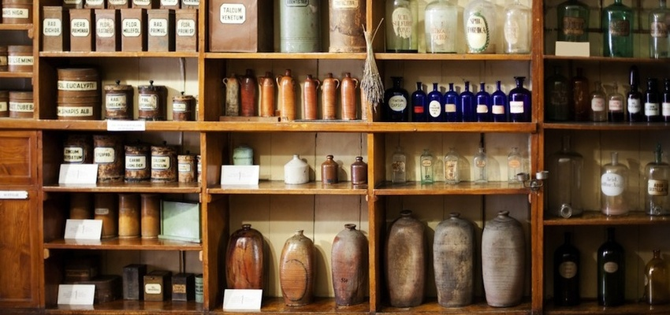In a neat planter box in the middle of the front porch is the earliest systematic compilation of medical treatments. This collection is attributed to an Egyptian official Imhotep (2667BC - 2648BC) . He designed the stepped pyramids at Saqqara and later for his brilliance he was elevated to become the god of healing, the only non-pharaoh to be divinized.

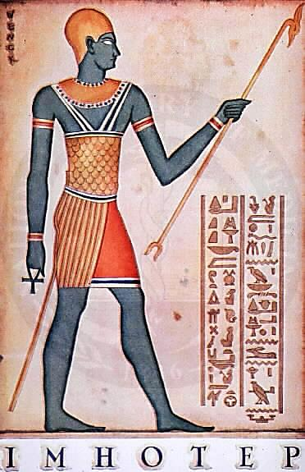
Imhotep extracted medicine from plants. A research team from the University of Manchester have recently shown that Chancellor Imhotep’s era kicked off a structured system of medical treatment two thousand years before Hippocrates. Prof Rosalie David, said: "These results are very significant and show that the ancient Egyptians were practising a credible form of pharmacy long before the Greeks. This has been looked at before but there has never been the firm scientific evidence that has come up in our project."

But there is more. We are moving now from the garden to the threshold of the house.

On the east side of the threshold, a cabinet contains a large papyrus. From the Smith Papyrus we learn that ancient Egyptian medical care was not limited to the magical modes of healing demonstrated in other Egyptian medical sources. Practices were constructed through observation and examination. The document itself is primarily a triage text, though some treatment options are offered for over 200 diseases including tuberculosis, gallstones, appendicitis, gout and arthritis. He may not have quite done it himself but his school of thought also performed some surgery and dentistry. He also knew the position and function of the vital organs and circulation of the blood system. He uses honey as antiseptic, and identifies the role of brain injury and crushed vertebrae in paralysis. He worked in the royal court, so for all his genius he is the ground floor.

On the western side is a statue of Hippocrates and some other books.

Hippocrates was associated with the healing shrines of Aesclepious of Greece and Rome. One book shows pictures of engravings from the shrines of Asclepious, giving diagnoses and treatments. Asclepious was a greek god, son of Apollo, famous for being zapped by god with lightning, The name is best known for the healing shrines around the greek-speaking world called Aesclepions, famously in Epidaurus and also Kos where Hippocrates would later learn this art and turn it into a science. If you went to an Asclepion you would normally receive diagnosis not by physical examination but by priestly divination and sometimes with treatment by a herbalist or a ritual. However, at the Asclepion at Epidaurus has three stone engravings listing 70 cases including some surgery using anaestheia by opium. Clearly, technically sophisticated remedies.

The other books are larger and more detailed and are dedicated to Hippokrátēs; c. 460 – c. 370 BC) He was a physician of Classical Greece and is referred to as the "Father of Western Medicine" , the founder of the Hippocratic School. This intellectual school revolutionized medicine in ancient Greece, establishing it as a distinct discipline and profession. Very little is known about what Hippocrates himself actually thought, wrote, and did, but his school credits him with coining the Hippocratic Oath, with greatly advancing the systematic study of clinical medicine, summing up the medical knowledge of previous schools, and prescribing practices for physicians. The original Hippocratic Oath was a promise to deliver a faithful service of healing to all, and used to begin with the invocation to several Greek gods and goddesses: "I swear by Apollo the Physician and by Asclepius and by Hygieia and Panacea and by all the gods ...".

On the floor between these books is a very large red rug from the area known as present day Turkey.
If Hippocrates was the foundation of Greek medicine, the apex was Galen. He came from Pergamon (129 –216AD) not far from Hippocrates’ island of Kos in Turkey (then Greek-speaking) he later practiced in Rome. He pioneered and documented medical work in surgery, pharmacology, physiology and anatomy and philosophy. His family were guided by the god Asclepios. The first major translator of Galen into Arabic was the Syrian Christian Hunayn ibn Ishaq. Hunayn translated (c. 830–870) 129 works of Galen into Arabic which formed one foundation of Islamic Medicine far ahead of medieval European medicine. Galen’s philosphy spread widely and his reference works endured until the 17th century.

In medicine he was essentially a humourist, that is, in the sense that he believed ‘the balance of humours’ gave one health, not in the sense of a comedian. However he learnt also from the very physical science of dissection of animals. Incidentally, Galen was quite keen on the therapeutic value of blood-letting, but that has now been taken over by journalists. Who’s a humourist now then?!

Inside the rug leads to some rooms inside the house that look Indian. One is the Ayurvedic tradition, whose therapies have been evolving over three millennia. There is a very old table holding two even older texts that are foundational, Sushruta and Charaka. Sushruta begins with the legend of the transmission of medical knowledge from the gods to sages and thence to human physicians.

“The Collection of Sushruta” is a systematic compilation of surgical techniques, with 184 chapters, listing 1,120 conditions, and 120 surgical instruments. It lists procedures including caesarean section and plastic surgery, plus some pathology, anatomy, midwifery, biology, ophthalmology, hygiene, a little psychology and bedside manner. Therapies are typically complex herbal compounds.

The other ancient source is Charaka, “the father of Indian medicine”, a scholar of 2000 medicines. According to Charaka's translations, health and disease are not predetermined and life may be prolonged by human effort and attention to lifestyle. Prevention of diseases has a more prominent place than treatment, including aligning lifestyle with nature and the four seasons for complete wellness. The following statement is attributed to Charaka:
“A physician who fails to enter the body of a patient with the lamp of knowledge and understanding can never treat diseases. He should first study all the factors, including environment, which influence a patient's disease, and then prescribe treatment. It is more important to prevent the occurrence of disease than to seek a cure.”

He studied physiology, etiology, embryology. He was the first physician to present the concepts of digestion, metabolism and immunity. Illness is an imbalance of the three doshas (humours). To restore the balance he prescribed medicinal drugs. Although he was aware of germs in the body, he did not give them any importance. We will come back to his work in the Step Two.

Chakara was himself preceded by Agnivesa, and Atreya, who had written an encyclopedic treatise in the 8th century B.C. Charaka revised this treatise , Charaka Samhita, and for two millennia it remained a standard work.

These rooms hold Indian traditions of great and ancient genius. The international scholarship in all the downstairs rooms and gardens is phenomenal. But we still haven’t found our way upstairs to common healthcare and evidence-based medicine.

Let me summarise so far.

We are still on the ground floor. Romans and Greeks built shrines and clinics and indigenous persons went to “medicine-men and women”. Every culture loves their loved ones and tries to heal their sick. Some do so with great genius.

The Indian scholar Vishal Mangalwadi, standing where Ayurvedic medicine began, stated that the best healthcare in history tended to be reserved for the rich and powerful and their favourites. So when I get sick, or fall off my motor-cycle, how come I expect that I will be taken into hospital, there will be a room for little me?

This is the next most important question, not the question of genius but of generosity. Who pioneered such a community healthcare system? Or in my extended analogy, who put in the staircase and built the upper story with rooms for all? Step Two will tell that story.

STEP TWO PIONEERS OF SCIENTIFIC MEDICINE

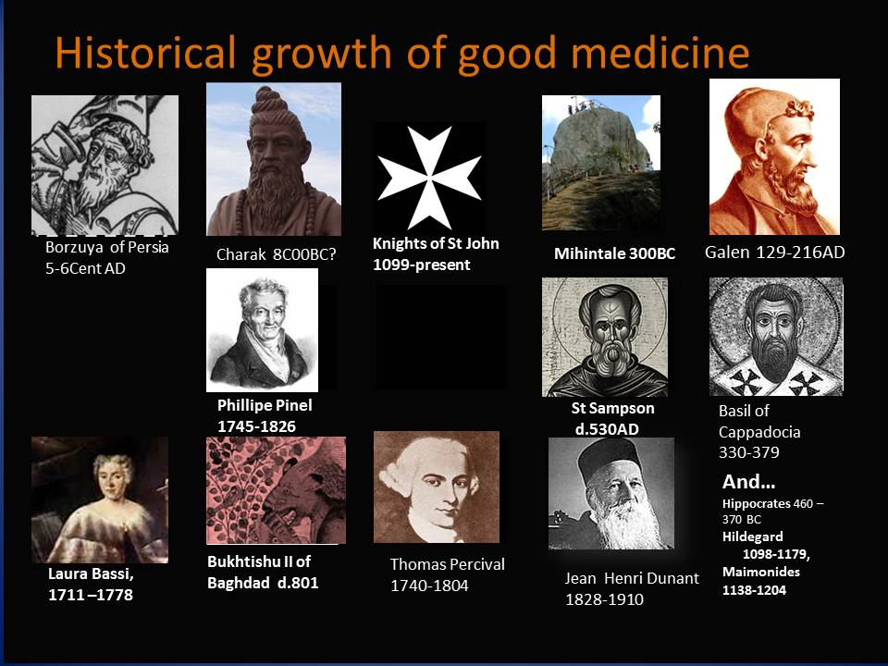

Here are three very early claims that point us to the stairway, but mind your step.

The claim for the earliest hospital system is found in the very centre of the Ashoka era, which became a great flowering of Buddhist culture, in Mahintale in India on the Ganges in the 3rd century BCE. In the early fifth century CE it was described by a Chinese Buddhist pilgrim to India, Fa Xian:
"The heads of the Vaisya [merchant] families in them [all the kingdoms of north India] establish in the cities houses for dispensing charity and medicine. All the poor and destitute in the country, orphans, widowers, and childless men, maimed people and cripples, and all who are diseased, go to those houses, and are provided with every kind of help, and doctors examine their diseases. They get the food and medicines which their cases require, and are made to feel at ease; and when they are better, they go away of themselves."

This fabulous description is one of the earliest accounts of a civic hospital system anywhere in the world. Sadly, it did not spread or endure though its remnants were still there 700 years later to be viewed by Fa Xian.

Another bottom step is Kashmir, date uncertain, possibly earlier? We have seen already that Charaka was one of the principal contributors to the science and philosophy of Ayurveda, a system of clinical medical practise and lifestyle. Charaka is sometimes dated to c. 800 BC but it is very uncertain. Like Hippocrates, Charaka is also referred to as the Father of Medicine. To this genius we could add Sushruta surgery, plastic surgery, massage and aromatherapy. Thus, India may have been the first part of the world to have organized a system of institutionally-based healthcare.

However, Vishal Mangalwadi reports again from modern India that three things failed to build the culture of compassion (karuna), despite its original brilliance. The cult of the Guru stifled innovative learning, the doctrine of Karma made it obligatory to leave people in their suffering, and the politics of Caste restricted the benefits of medicine to the wealthy. These three things he says, using Buddhist language, resulted in ‘detachment from care’.

Thirdly, the Romans built some buildings called valetudinarian, with wards and potions, so were they early hospitals? It is now thought that they treated only sick slaves, gladiators, and sometimes ailing soldiers. They were not for the wider community. Charity hospitals for the poor and indigent public did not exist until Christianity introduced them.

Saving physically frail, unwanted children was an affront to the Romans. It violated their cultural norms. Recall the words of Seneca, the first-century Roman philosopher : “We drown children who at birth are weakly and abnormal” (De Ira 1.15). Schmidt p 153

“When epidemics broke out,” says Howard Haggard, the Romans “often fled in fear and left the sick to die without care.” They saw helping the sick person as a sign of human weakness; whereas Christians, in light of what Jesus taught about helping the sick, believed they were not only serving the sick but also serving God. Schmidt p 153

So, these steps may be a bit shaky under foot. Hospitals did not spread in the Ganges area in the way that later greek-speaking christians were to spread them. Even today, he says, local village herbalists are called Unani Dawakhanas – transl. Greek Medical Houses. Where did this idea of commonly available Greek medical centres come from? These are not the same herbalists of ancient cultures, because they are named as an imported system. We have suddenly come across the crucial first step on the staircase. India’s debt for Greek medical care is owed to a bishop named Basil.

(pictured Basil and his theological college in Cappadocia)

Not the Basil of Fawlty Towers on TV. Basil of Caesarea Cappadocia 330-379 had attended a church Council at Constantinople in 360CE, one of the first public meetings after the church was freed from centuries of persecution and became legal. He returned with the idea of a hospital beside every church. He built a large complex outside Caesarea which included a poorhouse, hospice, residences and hospital. The “Basiliad” was regarded at the time as one of the wonders of the world. Yet it wasn’t his idea alone.

We know that at the same time, far away in Rome and in a different language, the lay-woman Fabiola was building two hospitals, working in them herself before she died c.399. Was there an idea that got about the Church Council? Did someone say over lunch – “wouldn’t it be crazy if we could set up hospitals everywhere for everyone (they all laughed ) It’ll never happen.”
It happened. Both initiatives endured and spread.

Despite the legacy of Galen and Hippocrates downstairs, the Basils were radical in their day. “When epidemics broke out,” said medical historian Howard Haggard, (“The Doctor in History” Yale University Press) “the Romans often fled in fear and left the sick to die without care.” They saw helping the sick person as a sign of human weakness; whereas Christians, in light of what Jesus taught, believed they were not only serving the sick but also serving God. Schmidt p 153

The pagan emperor Julian 361-363CE looked at this phenomenon and lamented the lack of humanitarian behaviour on the part of the Romans:
“Why do we not notice that it is [the Christians’] benevolence to strangers, their care for the graves of the dead, and the pretended holiness of their lives that have done most to increase atheism [=turning away from idols]? For it is disgraceful that, when no Jew ever has to beg, and the impious Galileans [Christians] support not only their own poor but ours as well, all men see that our people lack aid from us. Teach those of the Hellenic faith to contribute to public service of this sort.”

This debate continues today.

SPREAD

Let me frame this in context. As soon as the church was allowed to emerge from persecution, to enter into public life, to own any buildings, they built public hospitals everywhere. They used all the medical knowledge they could find both from international and interfaith sources, and they prayed in their liturgies for the anointing and healing of the sick. Herbs, medicine and prayer.

In our house of healing, we have reached the top of Basil’s staircase and there is a whole suite of rooms. By the middle of the sixth century in most of Christendom, that is from Britain to China, hospitals were being established. Some maintained libraries and training programmes and doctors compiled their medical and pharmacological studies in manuscripts. Speaking of the health system (not of personal genius and occasional institutions) established broadly across eastern and western empires, it is these Christian hospitals that revolutionized the treatment of the poor, the sick, and the dying. So in-patient medical care ( like a hospital today) was NOT solely an invention of Christian mercy or genius. The Christian gift was that it was widely spread, established for the common good and sustained as a public priority over the narrower demands of wealth and power. That gift needs defending today.

The gift was given to the world. Within a few centuries, Christians carried and shared this gift far and wide – scientific, international and interfaith. Today , the hospitals of Mercycare, St John of God, Wesley hospitals and so on, are not peripheral to the system of healthcare, but bear witness to the very core of the tradition. They stand for a particular value of compassion, at personal risk, a vision of all humanity being worthy, and a belief that all truth and knowledge is the knowledge of God. We will come back to these principles.

DISCUSS: Draw a diagram to represent the influences described in this history so far.

ISLAMIC MEDICINE

There is another corridor of rooms, Islamic medicine. The first prominent Islamic hospital, it is said, was founded in Damascus around 707CE with assistance from the Greek-speaking Christians. Soon after, the establishment at Baghdad became the most influential Islamic hospital.

Ath-Tha 'ālibi, a scholar of pre-Islamic Persia describes the eclectic development of medicine in Persia:
Thus, the people of [Susa] became the most skilled in medicine of the people of Ahwāz and Fārs because of their learning from the Indian doctor [who was brought to Susa by Shāhpur 1 r.240-270] and from the Greek prisoners who lied close to them; then [the medical knowledge] was handed down from generation to generation.

There are those Indian and Greek physicians again. In this and other ways we see that our Upper-floor rooms of Islamic medicine were first sparked by the Christian tradition. The Buhktishu family, eastern Christians ( the name means ‘servant of Jesus’) spanned 250 years of the 7-9 centuries. They are the ones most credited with the establishment of Islamic medicine. They worked out of the Academy of Goondishpar, which has a claim to be the first university, founded by Christian physicians.

Gondeshpar medicine in turn owed its origin to the Nestorian Christians from Edessa 489 AD and later to others fleeing persecution by the Byzantine emperor 529. Scholars translated Indian texts on astronomy, astrology, mathematics and medicine and Chinese texts on herbal medicine and religion. By the sixth century the city was famous for its theological school, and eventually the church also took charge of the secular medical institution. That needs to be stated because historians like Cyril Elgood are famous for saying :
“[T]o a very large extent, the credit for the whole hospital system must be given to Persia.” —Cyril Elgood, A Medical History of Persia (1951).
However we have seen that two centuries earlier the Cappadocians pioneered that hospital system, while Gundishpar took it a great leap forward and it spread back across the Muslim world and Asia.

The Al-Qairawan hospital and mosque, in Tunisia, were built under the Aghlabid rule in 830.
The first hospital in Egypt was opened in 872 and thereafter public hospitals sprang up all over the empire from Islamic Spain and the Maghrib to Persia. Later, Hunayn ben Ishaq a Christian from Baghdad in the ninth century translated medical texts from the Syriac tradition into Arabic. Building upon their legacy, the great Iranian Muslim named Avicenna (10-11C CE), famous for his herbalist text, also combined the received work of the greeks Galen and Dioscorides, with Iranian, Chinese and Indian texts. In contrast to medieval Europe, medical schools under Islam did not have academic faculties and certification, but that is a matter of educational organisation, not the quality of medicine.

We should add Rambam. Maimonides of Spain 1138-1204 was a great Jewish scholar, theologian and physician. He wrote ten known medical works in Arabic that have been translated into contemporary English.

THE RED CROSS AND RED CRESCENT

Jean Henri Durant was a Swiss businessman who when he accidentally witnessed the Battle of Solferino, felt called by God to establish what would become known as the Red Cross. He said:
“In this pent up emotion which filled my heart, I was aware of an intuition, vague and yet profound, that my work was an instrument of His Will; it seemed to me that I had to accomplish it as a sacred duty and that it was destined to have fruits of infinite consequence for mankind.” (Kennedy p 151)
In this pursuit, Dunant was to become bankrupt and homeless, to be expelled from the Red Cross executive after many conflicts with his co-founder Gustave Moynier. When he was awarded the first Nobel Peace Prize 1901his reputation was rehabilitated.
Dunant’s words on his deathbed: “I am a disciple of Christ as in the first century, and nothing more.”

How did the Christian cross become the visual symbol of the work? In 1906, Turkey , a Muslim nation that sought to move away from the Red Cross to the Red Crescent, complained that the flag took its roots from Christianity. At that point the story was adopted that the Red Cross flag had been formed by reversing the colours of the flag of Switzerland (Dunant’s home).

DISCUSS
Name the variety of ways in which faith has influenced the invention and the spread of healthcare systems?

SUMMARY

In the pre-modern centuries, we see a universal ground floor pre-occupation with finding remedies that work, and various scientific understandings of the ways of the human body. So, there are many rooms of genius in medicine, but one long standout staircase to the growth of access to public healthcare.

STEP THREE

IS THE PIVOTAL ROLE OF “BELIEVERS” MERELY A LEFTOVER FROM THE DARK AGES?

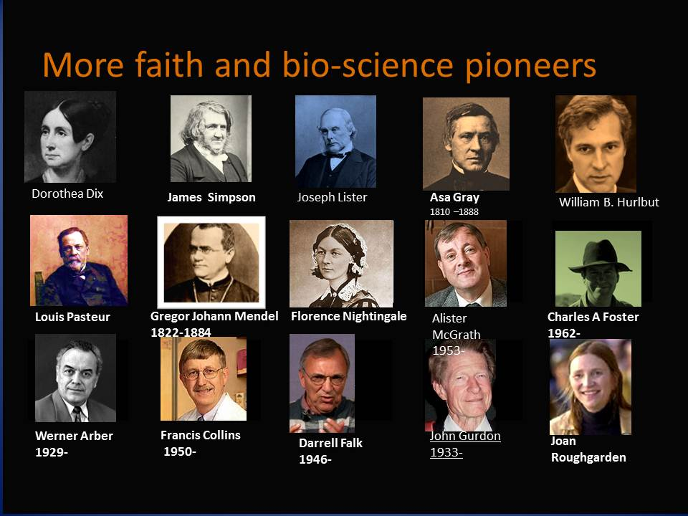

By the mid 1500’s there were 37,000 monasteries that cared for the sick (Schmidt p 157), following the Basiliad model, where medically educated monks and nuns cared for the sick. King Henry VIII closed down the monasteries in a stroke of matrimonial need, then went ‘oops’ when he realized he had closed the hospitals, so by directly funding hospitals they began to be secularised.

Secularisation did not stop the continued input of Christian pioneers of medical science. I want to illustrate this in such a way that leaves no impression that the claim of modern Christian sustenance to the medical science system was not led by conformists who were merely loosely aligned, or those who can say that ‘grandfather was a vicar or such”, or those who share the mixed good fortune of being born into a culture with Christian influence.

THREE MEDICAL PIONEERS WHO ARE PEOPLE OF FAITH.

Yes there are many excellent medical scientists in this story who held a genuine faith. Or were they, as claimed by the late Christopher Hitchens, just conforming to the Christian status quo, keeping out of trouble, while secretly being atheists? It is a tidy little conspiracy theory.

I am very conscious that the same sort of exaggerated claims are manufactured in the opposite direction also, that is, where too much credit is given to church or to a christian heritage.
In this research I have sifted through many claims that borrowed a line out of context here and recruited a person to their cause there. Let’s face the question of genuine faith or social conformity.

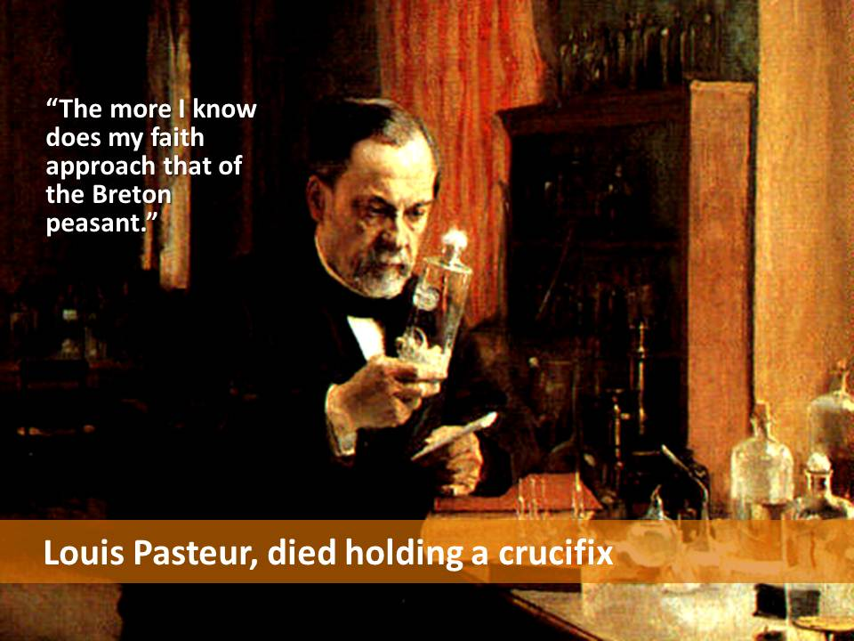
The Presbyterian dissenter Thomas Percival made major contributions in occupational health, epidemiology, and codes of conduct.

Louis Pasteur discovered that bacteria cause disease, and was laughed at.

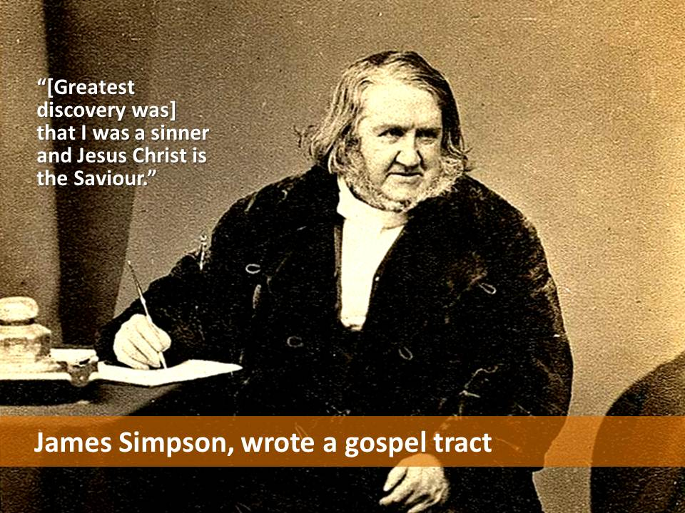
James Simpson invented chloroform, therefore modern anaesthesiology. “[Greatest discovery was] that I was a sinner and Jesus Christ is the Saviour.”

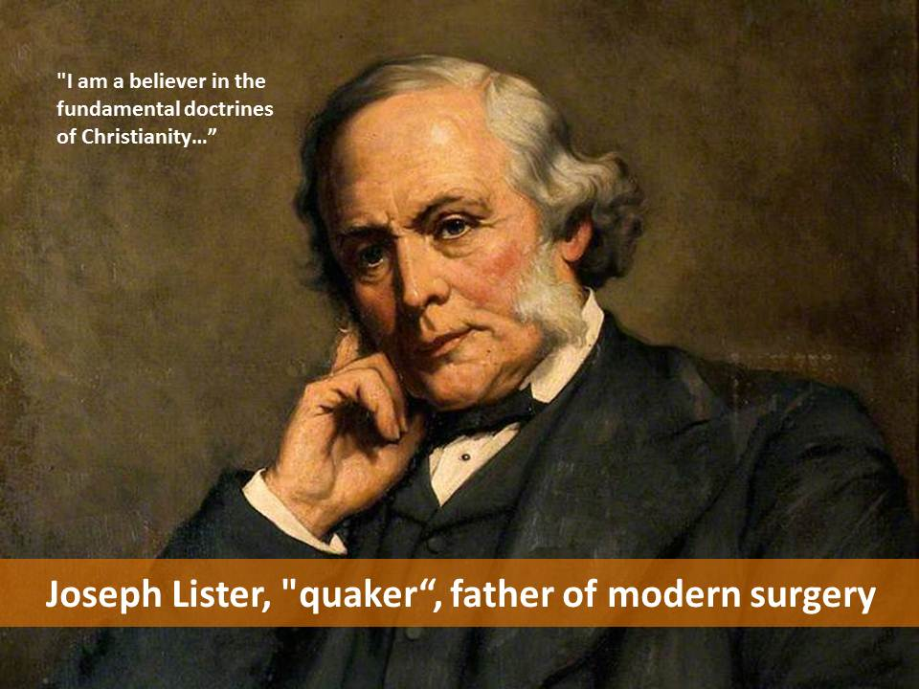
Joseph Lister (of Listerine fame) discovered antiseptics to quell germs and taught physicians to wash their hands, or at least he tried to. "I am a believer in the fundamental doctrines of Christianity." He told a graduating class: "It is our proud office to tend the fleshly tabernacle of the immortal spirit, and our path, if rightly followed, will be guided by unfettered truth and love unfeigned. In pursuit of this noble and holy calling I wish you all God-speed."

FLORENCE NIGHTINGALE, 1820 –1910

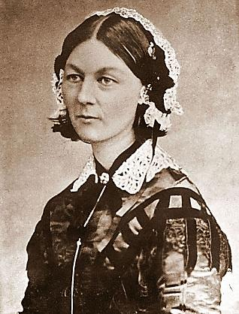
Florence said that she heard a call from God in February 1837, to devote her life to the service of others. She entered the nursing field in 1844, despite the intense distress of mother and sister, who expected her to fulfil the role for a woman as a wife and mother. She educated herself in the art and science of nursing.

In 1860 she founded a school of nursing at St. Thomas Hospital in London. It was the first secular nursing school in the world, now part of King's College London. The Nightingale Pledge taken by new nurses was named in her honour. Annual International Nurses Day around the world on her birthday.

Her other social reforms include improving healthcare for all sections of British society, also in India, helping to abolish laws regulating prostitution that were overly harsh to women, and expanding the acceptable forms of female participation in the workforce.

Was she a Feminist? She criticised early women's rights activists writing, "I have never found one woman who has altered her life by one iota for me or my opinions."

She published medical knowledge in simple English for those with poor literary skills. She also helped popularise the graphical presentation of statistical data. There is also a posthumous publication of her writing on religion and mysticism.

She was a Wesleyan sort of Church of England member throughout her life. She felt that genuine religion should manifest in active care and love for others. Nightingale believed religion helped provide people with the fortitude for arduous good work, and would ensure the nurses in her care attended religious services. critical of organised religion, including the role sometimes played by the 19th century Church of England in worsening the oppression of the poor.

A dying young prostitute being tended by Nightingale was concerned she was going to hell and said: 'Pray God, that you may never be in the despair I am in at this time'. The nurse replied "Oh, my girl, are you not now more merciful than the God you think you are going to? Yet the real God is far more merciful than any human creature ever was or can ever imagine."

Beside her intense personal devotion to Christ, Nightingale believed for much of her life that the pagan and eastern religions also contained genuine revelation. She was a strong opponent of discrimination both against Christians of different denominations and against those of non-Christian religions.

While she held that the ideal health professional should be inspired by a religious as well as professional motive, she said that in practice many religiously motivated health workers were concerned chiefly in securing their own salvation and that this motivation was inferior to the professional desire to deliver the best possible care.

DISCUSS:
Would you have called Nightingale a feminist?
Would you have called hera Christian?
Would you have agreed with her rigorous non-discrimination?

Presenter note: choose from these characters those you find interesting and do not try to talk about them all. You may even skip this slide and go straight to the next.

Here is a further sample of such pioneers. Moving into the twentieth century, here are some more of the great figures in biomedical science.

In the same field as Charles Darwin, a christian and botanist Asa Gray was his American friend and collaborator.

Gregor Mendel the Augustinian monk and geneticist and others were holding faith and biological science together creatively in pursuit of the wonder of God’s handiwork. The monk Mendel discovered the concept of genes and the discovery of his three laws: the law of segregation, the law of independent assortment, and the law of dominance.”

In genetics today, it was the Christian Francis Collins who headed the US Human Genome Project in pursuit of what he called ‘the fingerprints of God’... He is the current director of the National Institutes of Health. He has also written on religious matters in articles and in Faith and the Human Genome he states the importance to him of "the literal and historical Resurrection of Jesus Christ from the dead, which is the cornerstone of what I believe." He wrote the book The Language of God: A Scientist Presents Evidence for Belief.

Werner Arber (born 1929) is a Swiss microbiologist and geneticist. Along with American researchers Hamilton Smith and Daniel Nathans, Werner Arber shared the 1978 Nobel Prize in Physiology or Medicine for the discovery of restriction endonucleases. In 2011, Pope Benedict XVI appointed Arber as President of the Pontifical Academy—the first Protestant to hold that position. He is reported to be a Darwin sceptic but I am not sure in what way.

William B. Hurlbut (born 194?) is a physician and Consulting Professor at the Stanford Neuroscience Institute. In addition to teaching at Stanford, Hurlbut served for eight years on the President's Council on Bioethics.

Darrel R. Falk (born 1946) is an American biologist and the former president of the BioLogos Foundation, a faith-science think tank based in Oxford UK.

Charles Foster (born 1962) is a science writer on natural history, evolutionary biology, and theology. A Fellow of Green Templeton College, Oxford, the Royal Geographical Society, and the Linnaean Society of London, Foster has advocated theistic evolution in his book, The Selfless Gene (2009).

Sir John Bertrand Gurdon (b 1933)is a British developmental biologist. In 2012, he and Shinya Yamanaka were awarded the Nobel Prize for Physiology or Medicine for the discovery that mature cells can be converted to stem cells. In an interview with EWTN.com on the subject of working with the Vatican in dialogue, he says "I'm not a Roman Catholic. I'm a Christian, of the Church of England...I've never seen the Vatican before, so that's a new experience, and I'm grateful for it."

In the United States Dorothea Dix (1802-87). An avowed Christian began in the Civil War directing nurses and assisting wounded and dying soldiers. She also travelled to many states and to Britain in her efforts to obtain better care and treatment for the mentally disturbed. Appalled by the inhumane treatment of the insane, at the Massachusetts state legislature, she declared, “I dishonour you, divest you at once of Christianity.” Resented by many physicians and ignored by intellectuals, she also tried to get authorities to improve prisons and poorhouses.

Lest it be thought that all Christians are Creationists and conservatives, Joan Roughgarden (born 1946) is an evolutionary biologist who has taught at Stanford University since 1972. She wrote the book Evolution and Christian Faith: Reflections of an Evolutionary Biologist, where she emphasizes her belief that the Bible does not conflict with evolutionary biology and relates Christianity and evolution by asserting that all life is interconnected. In 2004 Roughgarden published a challenge to sexual selection titled Evolution's Rainbow: a critique of Darwin's sexual selection theory based on multiple instances of animals where it is not the case that the male attempts to impress the female, and the female chooses her mate. In The Genial Gene (2009) she presented an alternative social-selection theory. Roughgarden opposes the theories of creationism and intelligent design, but asserts her belief in God's involvement in evolution.

CONCLUSION

This completes this short survey of excellent medical pioneers who were people of faith. With my milk pasteurised, my hands clean, my mouth fresh, and definitely a voice of dissent, I offer to you that there is nothing conformist about any of that lot. The trend may even be the opposite – shock and horror - that the authenticity and adventure that come from a dissenting faith may actually build the required tenacity that aids creative science. Too rarely is faith acknowledged as an authentic and vital position for science.

DISCUSS
What would makes you think one way or the other whether these scientists were genuinely believers or were they just conforming to the establishment norm in the society around them?

A WIDE MOVEMENT NOT JUST ACCIDENTAL INDIVIDUALS

These pioneers of medical science are undisputed in their genius and contribution. Many of them revealed some defining factor that points to a genuine Christian faith, and earlier centuries include also Buddhist and Islamic faiths. Their genius was not therefore that of simply an individual.

We have seen that the science of medicine has contributors form every culture. What of Christian involvement in the spread of access to hospitals?

MONKS AND NUNS, EARLY NURSING SCIENTISTS
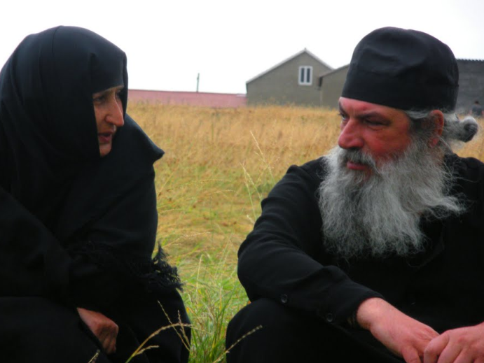
Medieval hospitals in Europe followed the Byzantine pattern. Care was provided by monks and nuns. Some were attached to monasteries; others were independent and had their own endowments for their support. Some hospitals were multi-functional while others were founded for specific purposes such as leper hospitals, or as hostels for the poor or pilgrims.
Spain: 580AD at Merida.

Italy: In Italy, throughout the monasteries, you would be fed ‘Ministrone’ soup, the everything in one pot food named as ‘ministry’ which means service to the poor and weak. The Ospedale Maggiore, (i.e. Big House), in Milan, housed one of the first community hospitals, the largest such undertaking of the fifteenth century. It is among the first examples of Renaissance architecture in Lombardy.

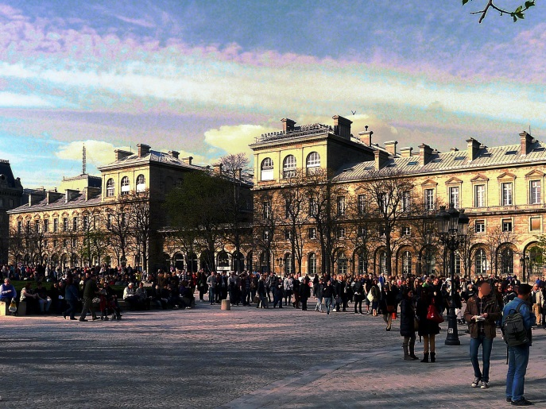
Britain: The Normans brought their hospital system along when they conquered England in 1066. There the system merged with traditional land-tenure and the widespread charitable houses became popular. They were distinct from both English monasteries and French hospitals. They dispensed alms and some medicine, and were generously endowed by the nobility and gentry who were motivated by spiritual rewards after death. An old French term for hospital is hôtel-Dieu,(pictured) "hostel of God.“ which persists to this modern hospital in Paris.

MENTAL HOSPITALS
Lets turn from general medicine to mental hospitals We have already mentioned the role of Dorothea Dix (1802-87) :“I dishonour you, divest you at once of Christianity”, improving conditions and treatment for the insane in all American states. It is less well known that these principles was not an invention by Dix but a recovery of earlier practise.

In 321, bishops and monks founded houses for the care of the mentally ill, including care within the monasteries themselves.
In line with the development of their hospital system, the first Islamic psychiatric hospital opened in Baghdad in 705. Many other Islamic hospitals also often had their own wards dedicated to mental health.

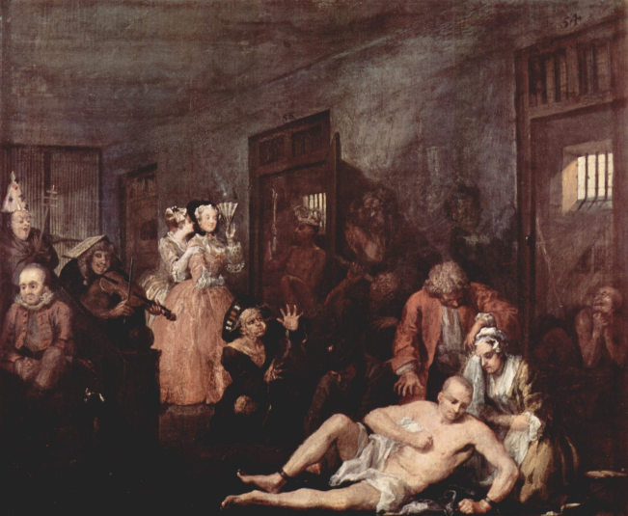
1369 London a hospital was founded “for poor priests and others, men and women, who in that city suddenly feel into a frenzy.” A Christian insane asylum was present in 1409 in Valencia, Spain.

In the later Middle Ages, humane treatment was often abandoned. Ill people were incarcerated, chalked, treated as less than human, often with physical punishment and chained confinement. They were sometimes regarded as wild animals.

In 1540, when King Henry VIII dissolved the monasteries in his dissension with Rome, her simultaneously closed the community hospitals. Only by direct petition from the citizens of London , the hospitals of St Bartholomews, St Thomas’s and the Priory of St Mary of Bethlehem (pictured, the Bedlam, a mental hospital) were endowed directly by the crown. This was a major step into secular establishment of hospital care.
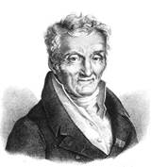
In the modern era, we are indebted to Phillipe Pinel (1745-1826). He was a French physician and one-time divinity student who saw the patients as sick rather than criminal. In Bicetre, France, he defied the authorities, and cut loose the chains of some of the inmates, an act thought to be insane. He showed the inmates love and kindness and the inmates were able to respond.

As a Christian, Pinel showed compassion reminiscent of Jesus’ acts towards the sick and ailing. The Frenchman’s unusual behaviour is responsible for a real paradigm shift with respect to treating the mentally disturbed. This shift did not come easily, as the preaching and pressure by Dorothea Dix shows, but he also had antecedents. In 1709, the Quakers in the United States erected a general hospital in Philadelphia that housed “lunaticks.” This hospital succeeded, and after Pinel, in 1841 the Quakers opened a separate building just for the insane.

NURSING ART AND SCIENCE

Where do we look for the history of medical nursing ?

Widows, deaconesses, and virgins commonly served as nurses in the early Christian hospitals.
Paula (374-404), and Fabiola (pictured) were female associates of St. Jerome. Fabiola's legacy is the early leadership of Christian women in the field of medicine. As feminist history shows, this leadership role has remained difficult.
- Hildegard of Bingen is another medieval example.
- The Knights Hospitalers of St. John recruited women
- Thirteenth century, the order of Augustinian Nuns arose, which is the oldest nursing order of Roman Catholic sisters.
- Later, a Lutheran deaconess order, composed primarily of peasant women, were trained as nurses.
- And the large story in the modern era of enigmatic Florence Nightingale (above)

ST JOHNS AMBULANCE AND FIRST AID

The stonework (pictured) is from the small and ancient church of ST JOHNS in Jerusalem.
Something fantastic came from that tiny church to 42 countries.
http://www.orderofstjohn.org/who-we-are/our-history
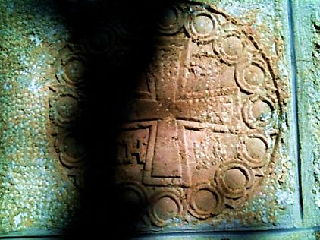
St John is a leading first aid, ambulance and care charity. It has a global membership of approx. 400,000 in 42 countries and has diversified to meet many health-care local community needs around the world, including relief work, disaster planning and HIV/AIDS services. St John Ambulance also provides the statutory ambulance service in some of its territories.

St John organisations are working with people all around the world from many different backgrounds and religions. Yet the Order is a Christian Order:
• founded on Christian principles;
• has a religious belief; and
• is motivated by Christian ideals.

It admits those people of different faiths, and no religious belief who, in good conscience, are able to support the aims of the Order as a Christian Order. That means that the Christian faith continues to inform, inspire and invigorate the work of the Order and that this faith remains integral to the Order’s identity and tradition. In 1999: The Order of St John celebrated its 900th anniversary worldwide. Incredible!

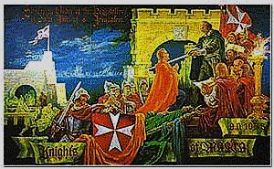
It began in Jerusalem and the Crusades. About 1070, a hospice was established in Jerusalem by Benedictine monks for pilgrims. It soon developed into a hospital and in 1113 the Pope gave official recognition to its work.

Over the next forty years it developed into a religious and military order, with its brothers and sisters (commonly known as Hospitallers of St John) providing care to the poor and sick of any faith.

Why did they need to be knights? Because they took on the additional role of defending all within their care. The rule of war which protects the sick had not yet been thought of.

St John’s church is the oldest in-use church in the old city of Jerusalem, because when the Muslim conquereors saw what they were doing they wanted them to continue.
From Jerusalem to Cyprus, Rhodes, then in 1530 to Malta, before being expelled by Napoleon in 1798, their medical work always continued. The great ward in Malta’s hospital was the longest room in 18th century Europe.

DISCUSS:
Is it strange to think that something as good as St Johns could come out of the terrible Crusades?

CHRISTIANS ARE STILL DOING “MEDICAL MISSIONS”

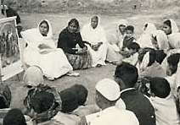
In this photo, a rural health education group in India is just one recent example of Christian medical missions.

You can read the text and maybe add the video.
Enabling the Disabled
from Interserve : On Track
Video visual only
http://www.youtube.com/watch?feature=player_embedded&v=_svUqrL5mjI Length 1.16 Uploaded Dec 21 2009
Text Reference: http://www.interserve.org.au/#pid=228

1 year assignment in Thailand
“Michael and Katy previously completed separate short term mission trips to Thailand where God gave them both a real heart for the Thai people. Michael is a physiotherapist and Katy is a primary school teacher. God has given them a strong desire to be involved in cross cultural mission and they are excited to be able to use their professional skills and experience in Thailand.
They are serving in a remote village. Michael is working in a project which assists more than 90 disabled children and adults to flourish despite their challenges through encouragement, teaching and various forms of therapy. Katy is teaching English in a local primary school with some 500 students! They are also involved in a local church.”

DISCUSS
What does it mean “God gave them a real heart for the Thai people”? Tell of a time when something like that happened to you, either slowly or suddenly?

CONCLUSION TO STEP THREE

The physician and medical historian Fielding Garrison once remarked, “The chief glory of medieval medicine was undoubtedly in the organization of hospitals and sick nursing, which had its organization in the teaching of Christ.”

Thus, whether it was establishing hospitals, creating mental institutions, professionalizing medical nursing, or founding the Red Cross and St John’s, the teaching of Christ lie behind all of these humanitarian achievements.
It is an astonishing mystery that the Greeks, who built large temples in honour of their numerous gods and goddesses, fashioned statues of all stones, and wrote a wide variety of illuminating literature, never built any hospitals. It is further astonishing when one remembers that while they had some medical facilities to diagnose people’s physical ailments, these units did not function as hospitals where the sick could be treated and get rest and recuperate. The situation was similar with the Romans, who were also great builders of temples, large arenas, impressive aqueducts, and the highly advanced Appian Way. While some historians believe the Romans did have some type of hospitals for its soldiers, they, like the Greeks, did not have hospitals for the general populace.
Schmidt -pg 166-167

The same policy and practise of compassion continued into the modern era, bringing healing in the name of Jesus the healer.

STEP FOUR
CHIEF GLORY

Christians tend to make strong contributions to healthcare when they follow the Jesus-model

We now move from persons and policy to principles. Whether it was in establishing hospitals, creating mental institutions, professionalizing medical nursing, founding the Red Cross or St Johns, or running disability services in India or in remote Thailand, the teaching of Christ lies behind it . The physician and medical historian Fielding Garrison once remarked:” The chief glory of medieval medicine was undoubtedly in the organization of hospitals and sick nursing which had its organization in the teaching of Christ”.

Wherever the church goes, a school and a hospital soon appear. Why?

JESUS AND HEALING

In the Bible read this short story from Mark Chapter 1,
“A man with leprosy came to Jesus and begged him on his knees, “If you are willing, you can make me clean.” Filled with compassion, Jesus reached out his hand and touched the man. “I am willing,” he said. “Be clean!” Immediately the leprosy left him and he was cured.”

In my imagination, it happened like this. Let’s call him Levi.

He had lost count of how many weeks since he got sick. Like a bomb in a Baghdad market, it just happened. It started when Levi saw a white patch on his arm when he went out to work the sheep. He poked it and it felt funny. ‘No worries. It will be all right’. But his worries had started there.

Yacov his cousin noticed it that day, and whispered to him at lunch: “You oughta see a doctor right away”. Doctor after doctor he saw, and none could help him, but they all took his money. The white patch spread to his shoulder. He lost all feeling in his skin wherever it went. When the bottom of his face went numb, his smile became lop sided and he looked gross. He wore a bandage to hide it. Everyone had noticed it now, and children stared at his bandaged face and neck, as though he was…, like he was,… it is hard to say it… like he was a leper. He had leprosy. They all believed back then that it was highly infectious. There was more panic around him than swine flu. You are ‘Unclean’ they sniped.

The officials told him he had to leave home immediately for the sake of his wife and children. No touch allowed. But how will I live without them? And furthermore he couldn’t go to work anymore for the sake of the other workers and their families. They made him wear a badge that said: Unclean. But how will I earn my food and housing? How will my family live?

He wasn’t allowed to go to church anymore, for the sake of the other families. No touch allowed. He couldn’t go to the shops or markets. Unclean. How will I eat? Or get clothes? or blankets? How can I ever survive? Is there no one I can be with – how will I stop from going insane? No touch allowed.

Week after week, month after countless month, as far as he was concerned the disease wasn’t fast enough. He wanted it to end. He could see his wife in tears only from a distance. He could watch his children play and go to school but they could only wave. No hugs, no kiss, no handshake, no drying of tears, no touch, none at all. The wasting face of the disease was ugly and they couldn’t even bear to look at him now. He felt like he was stuck somewhere in outer space. The pain of going on alive, so alone, was more than the pain of the wasting disease. ‘Life goes on’ other people used to say to him and he wished, wild and deep in his guts, that it didn’t.

Then Jesus came to the village. Levi had heard about him, and his healings. Why not try him? Levi couldn’t go in to the village, of course, so he had to hang around on the road out of town and just hope that Jesus came out that way. When he saw him coming, Levi’s heart jumped. Despite the hot sun, a small crowd also came with him, damn it, and Levi had to withdraw, hang back, out of the way and off the road, wanting for a space to approach Jesus.

Jesus just kept along the road, walking with purpose, but the towns folk didn’t go back. Jesus came another 50m closer and Levi had to back off yet again – no touch, unclean.

‘Maybe he won’t care after all. Maybe his eyes are for someone else. Maybe, maybe, oh I’ve had too many maybes too many doctors too many crushed hopes and here goes another one. He isn’t even looking this way. He won’t want to see me. If he comes near me they will send him to weeks in quarantine and look at how busy he is, how many people want him. He has healed so many. This guy is good news. Not for me. He won’t want to help me, …but …his heart leapt:
“Jesus” he shouted with an angry challenge, “you want to heal me!…don’t ya?”

Jesus looked suddenly, past the little crowd and saw a leper standing back, hiding away from the road. He saw Levi’s ‘unclean’ badge. Finding his face, their eyes locked and a smile appeared at the bottom of Jesus’ face. The little chattering crowd fell nervously behind as Jesus swung across the road, walked lightly around the bushes, straight up to the guy half-hidden in rags and shame and rage and badge and bandage fifty metres away.

Jesus reached out and touched him. It felt like a meteor strike. So when Jesus said: “I do want to. Be clean”, Levi knew he was.

That’s the end of the story. You might like to wonder why I reckon Jesus smiled.

JESUS COMMANDS

Kindness and caring is so central to Jesus that it is his clearest picture of the Last Judgement. To the point of fourfold repetition he describes what sort of faith he is looking for. On that last Great Day He will not, he says, ask us to articulate our theological position on inerrancy or our moral position on homosexuality or abortion. Only the Pharisees liked that stuff. Jesus says:

Mt 25:31 “When the Son of Man comes in his glory, and all the angels with him, he will sit on his throne in heavenly glory. All the nations will be gathered before him, and he will separate the people one from another as a shepherd separates the sheep from the goats. He will put the sheep on his right and the goats on his left.

“Then the King will say to those on his right, ‘Come, you who are blessed by my Father; take your inheritance, the kingdom prepared for you since the creation of the world. For I was hungry and you gave me something to eat, I was thirsty and you gave me something to drink, I was a stranger and you invited me in, I needed clothes and you clothed me, I was sick and you looked after me, I was in prison and you came to visit me.’

“Then the righteous will answer him, ‘Lord, when did we see you hungry and feed you, or thirsty and give you something to drink? When did we see you a stranger and invite you in, or needing clothes and clothe you? When did we see you sick or in prison and go to visit you?’

“The King will reply, ‘I tell you the truth, whatever you did for one of the least of these brothers of mine, you did for me.’

Deeds of caring compassion that would be typical of being done BY Jesus are here said to be done TO Jesus. That is the faith that saves. So simple. Yes, the caring Jesus sends his caring friends to a broken world, to care for one another as we care for his world.

Jn 13:34 “A new command I give you: Love one another. As I have loved you, so you must love one another.

Jn 13:35 By this all men will know that you are my disciples, if you love one another.”

The obvious implication of this is that the ceaseless compassion of God is predominantly seen in this world through the compassionate friends of Jesus, who do good thing on a routine basis, in the darkest places and hopeless cases. One of ancient Desert Fathers of the church, St Anthony said: “our life and death is with our neighbour’. If we are not being sent to care and to bless , we have no life within us.

All four of the Gospels reveal that along with his teaching, Jesus had compassion for the sick. He healed many. Matthew states that “Jesus went throughout Galilee… healing every disease and sickness among the people” (Matthew 4:23). He healed the blind, the lame, the deaf, the palsied, and even the lepers who were quarantined and considered social outcasts. Moreover, his healing acts were never divorced from his concern for people’s souls, their spiritual well-being. “For him no healing was complete which did not affect the soul.” Christ was a holistic healer!
Schmidt -pg 151

The New Testament Greek word sozo as applied to Jesus activity means both “save” and “heal.”
As noted above, Jesus expected his disciples, along with their preaching and teaching, to heal: “He sent them [the twelve disciples] out to preach the kingdom of God and to heal the sick” (Luke 9:2). As he commissioned the seventy to enter towns, he gave them a similar message: “Heal the sick who are there” (Luke 10:9). And as the early Christians were dispersed throughout Asia Minor, largely as a result of being persecuted, we find them engaged in healing in addition to their preaching and teaching The New Testament, especially in the Acts of the Apostles, cites a number of instances where Peter, Paul, Stephen, Barnabas, Ananias, and other Christians healed people as part of their missionary activities. Schmidt -pg 151-152

THE EARLY CHURCH PRACTISED HEALING – by Rev Dr Ric Barrett-Lennard

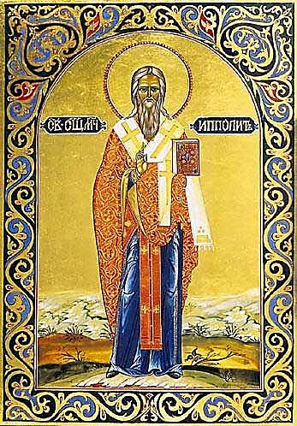
Liturgy reflects the underlying theologies and attitudes of those who develop them and to some extent, also, those of the communities for whom the liturgies are an expression of their worship. Many extant early Christian liturgies reflect a belief that Christ intended his followers to minister to the sick and to pray for their healing and accordingly they include prayers of various kinds for this purpose.

This is illustrated in the possibly third-century liturgy, The Apostolic Tradition and the fourth-century texts, The Sacramentary of Sarapion and, The Canon of Hippolytus which is based upon The Apostolic Tradition. The Sacramentary of Sarapion includes short prayers variously titled, “Prayer for the Sick”, “Laying on of Hands for the Sick”, “Prayer for Water and Oils that are Offered” and “Prayer for Oil or Bread or Water of the Sick.” The first of these begins this way:
We beseech you, the overseer and Lord and modeller of the body and maker of the soul, the one who constructed humanity, …. Be gracious, Master: help and heal all who are sick. Rebuke the sicknesses; raise up those who are bed-ridden ;…

In both The Apostolic Tradition and the Canons of Hippolytus there is a specific regulation relating to those exercising, “a gift of healing”, thereby indicating that in the third and fourth centuries there were still individuals recognized as having a particular charism of healing.

So the early liturgies gives us rich insight into the thinking and practice of the early Christians in this area.

THREE PRINCIPLES

The epicentre of this centuries-long world-wide broad-based movement is the role model of Jesus in serving the poor and the needy and in giving his life in sacrifice for others. The act of apparent weakness , a strategy despised by many, is shown through history and the New testament to turn out to be the winner by rising from the dead.

There are 3 Christian principles that have been driving the medical enterprise:

1. Already mentioned, The GOOD SAMARITAN principle is the formula for action
As a personal ethic The Good Samaritan role-model is difficult enough but politically the story was inflammatory. Jesus’ hearers would never have thought to follow the role model of the Samaritans that everyone else loved to hate, perhaps treated like today’s refugees or aboriginals. That’s the Christian formula for action in the neighbourhood and in politics. Jesus’ teaching is compassionate, costly, courageous, and seeks to cross socio-political barriers. Its cultural influence lingers somewhat in this post-christian generation, but its light may be fading.

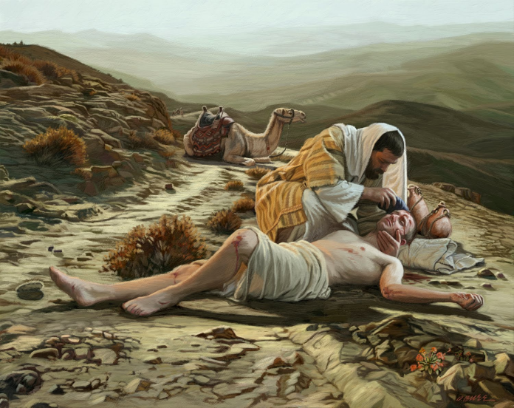
Please stop and read Luke 10:25-37.

²⁵ On one occasion an expert in the law stood up to test Jesus. “Teacher,” he asked, “what must I do to inherit eternal life?”
²⁶ “What is written in the Law?” he replied. “How do you read it?”
²⁷ He answered, “‘Love the Lord your God with all your heart and with all your soul and with all your strength and with all your mind’^{[a]}; and, ‘Love your neighbor as yourself.’^{[b]}”
²⁸ “You have answered correctly,” Jesus replied. “Do this and you will live.”
²⁹ But he wanted to justify himself, so he asked Jesus, “And who is my neighbor?”
³⁰ In reply Jesus said: “A man was going down from Jerusalem to Jericho, when he was attacked by robbers. They stripped him of his clothes, beat him and went away, leaving him half dead. ³¹ A priest happened to be going down the same road, and when he saw the man, he passed by on the other side. ³² So too, a Levite, when he came to the place and saw him, passed by on the other side. ³³ But a Samaritan, as he traveled, came where the man was; and when he saw him, he took pity on him. ³⁴ He went to him and bandaged his wounds, pouring on oil and wine. Then he put the man on his own donkey, brought him to an inn and took care of him. ³⁵ The next day he took out two denarii^{[c]} and gave them to the innkeeper. ‘Look after him,’ he said, ‘and when I return, I will reimburse you for any extra expense you may have.’
³⁶ “Which of these three do you think was a neighbor to the man who fell into the hands of robbers?”
³⁷ The expert in the law replied, “The one who had mercy on him.”
Jesus told him, “Go and do likewise.”

There it is. Christians have ‘gone and done likewise’ in their thousands throughout the world as the WXED series shows repeatedly. This short story is the single most transforming document on the planet.

DISCUSS
The healing work of Jesus was not just medicine but transformation for individuals and their communities. Why is it so, as Mangalwadi says: “wherever the church goes, a school and a hospital soon appear”?

Secondly , THE MEANING OF MIRACLES is that they are the Formula for attitude.

Jesus also performed healing miracles, which the Jewish historian at the time - Josephus Flavius - called ‘mighty deeds’. All the gospel writers report the same. Jesus did not heal everyone so this is NOT the formula for the action that the Good Samaritan is. That’s why churches normally build clinics and not magic shops.

I have myself been witness to two miracles so I can’t accept the theory that they are simply metaphors. Today, Miracles are the formula for attitude.

Jesus’ healings, John’s gospel says, are ‘signs’ that point in two directions.

One is that God is, at base, merciful not vengeful. That’s good news in this world, good to knopw with confidence that when God reveals himself unequivocally, it is with mercy not justice or vengeance.
The second part of the sign is to re-calibrate our minds away from feeling powerless and hopeless and expect here and now that God can do great things. The meaning of miracles is that Jesus is poised to do great things through ordinary garden-variety believers! Thus we have seen him at work nearly everywhere. I don’t know how you practise that on the ward!

The third principle is more at ease on the ward.

WHOLENESS OF LOVE - health is wholistic

The third principle is that health only rises wholistically. Everything connects, everything belongs. Some well known examples: physical exercise restores psychological depression, mental grief causes spiritual doubt, meaningless life-choices can cause mental and physical tiredness, etc.

So, firstly, it is no wonder then that scientific studies have now shown effectual connections between spirituality, prayer, wellbeing and healing. I mean many hundreds of academic studies with double-blind controls and so on. Google them for yourself. Depending on what aspect of illness or spirituality they were studying, the effective factor ranges from what a colleague recently called ‘small but statistically significant’ to a factor of 200% or 300% or in one heart-patient study even 14 times better health outcomes. Spiritual inputs, in other words, demonstrably defy the rumours that they are merely a placebo-effect or snake-oil.

Research focusing on the power of prayer in healing has nearly doubled in the past 10 years, says David Larson, MD, MSPH, president of the National Institute for Healthcare Research, a private nonprofit agency. "All of these studies, all the reports, are remarkably consistent in suggesting the potential measurable health benefit associated with prayer or spiritual interventions.” says Harold Koenig, MD, associate professor of medicine and psychiatry at Duke University. Religion provides what Koenig calls "a world view," a perspective on problems that helps people better cope with life's ups and downs. "Having that world view helps people integrate difficult life changes and relieves the stress that goes along with them…A world view also gives people a more optimistic attitude -- gives them more hope, a sense of the future, of purpose, of meaning in their lives. All those things get threatened when we go through difficult periods. Unless one has a religious belief system, it's hard to find purpose and meaning in getting sick and having chronic pain and losing loved ones."
"Nobody's prescribing religion as a treatment," Koenig tells WebMD. "That's unethical. You can't tell patients to go to church twice week. We're advocating that the doctor should learn what the spiritual needs of the patient are and get the pastor to come in to give spiritually encouraging reading materials. It's very sensible.“

Is its effect simply the power of suggestion, a placebo?

A placebo is any medical treatment that is inert (inactive), such as a sugar pill. Around one third of people who take placebos (believing them to be medication) will experience an end to their symptoms. This is called the placebo effect. Intercessory “success” rates are at best half that, but the comparison is flawed in the study that I read.
Is its effect a Nocebo? In the opposite effect, a patient who disbelieves in a treatment may experience a worsening of symptoms. This effect, now called by analogy nocebo (Latin nocebo = "I shall harm") can be measured in the same way as the placebo effect, e.g., when members of a control group receiving an inert substance report a worsening of symptoms. The recipients of the inert substance may nullify the placebo effect intended by simply having a negative attitude towards the effectiveness of the substance prescribed, which often leads to a nocebo effect, which is not caused by the substance, but due to other factors, such as the patient's mentality towards his or her ability to get well, or even purely coincidental worsening of symptoms.

The placebo/nocebo argument has now been informed by much richer studies

First, different aspects of spirituality were analysed and compared:
- Mainstream religious orientation.
- Unreflective religiosity
- Alternative spiritualities and their values separated:
- Orthodox religious beliefs
- Sense of purpose in life
- Stronger sense of control
- Contributing to others

They found that a person having a spiritual orientation, whether religious or broader, appears positively linked to some aspects of wellbeing. Those who would see a secular society as improving the wellbeing of Australians may need to reflect carefully on the results that are here.

They found further that it is important to separate out the various strands of a religious or spiritual orientation as each may have a different relationship with wellbeing.

They found that with many of our wellbeing measures, alternative spiritualities seem to perform differently to a religious orientation. e.g. While both are linked with contributing to others, there are differences reflecting different underlying values: those involved in alternative spiritualities are less likely to contribute to charities or to community groups, even after controlling for the effects of age and gender.

“While in terms of medical intervention it is clearly not a primary factor, nevertheless, in thinking about health and wellbeing issues in the wider population, the beneficial impacts of spirituality may well be deserving of attention.”

Scientific medicine, after all these published studies, if it is to preserve its integrity and public confidence, should simply do its science better and allow for the results of these spiritual practices.

The second aspect of holism, Jesus defined a whole person, a saved person, as one who loved God with all their heart soul mind and body and loved their neighbour as they loved themselves. It is simple, wise, wholistic, achievable, connected and comprehensive.

CONCLUSION

So holistic healthcare, wise and effective heathcare, will deliberately help love happen, not just efficiency, economy, professionalism, objectivity and other management-speke. The Franciscan Richard Rohr said: “Only love can be trusted with wisdom. All other attitudes will murder and mangle and manipulate truth for their own ego purposes.” Does that sound like your medical team?

Maybe I should call these powerful three principles: Seek, pray, love.

Let’s now widen the question to some other ways that the current issues facing medicine can be addressed by remembering these principles and by harnessing the strength and the humility and generosity that arises from a relationship with Jesus.
STEP FIVE
CAN CHRISTIANS CONTRIBUTE WELL TODAY?

“Thanks for the memories”, I hear you say, “but those days are gone. Mercy Care, St John of God, Red Cross etc continue as largely secular agencies. It is safer to banish religion from the corridors, that is ‘the God bit’.” What they mean is not actually God but a fear of being put under pressure to conform to belief in God. “You cannot trust Christians to act well or contribute equally. They demand privilege for their ideas instead of an open debate.”

THREE APOLOGIES
Despite all the positives, and partly because of them, I admit there are at least three ways in which Christianity has exercised a poor influence on healthcare. Therefore I offer THREE APOLOGIES as an ordained leader of the church, not merely for things we knew too late but for some things we knew but didn’t do, that is for heinous acts of hypocrisy.

Playing god

In the Good Samaritan story Jesus warned us that religious people might just walk on by and ignore the need. Despite such a great track record for healing, the church has often spoiled public discussions about issues of the boundaries of life - abortion, birth control and euthanasia. For example, the argument ‘life is sacred’ aims to close down discussion not participate. When the church complains that doctors are ‘playing god’ they are in fact making their own view absolute. The church must have a view but not a veto. We must take responsibility within life as it is in all its mess, not just define freewill or take the distant overview without particular compassion. In the environment created by such corrupt thinking, no wonder that some religious leaders have acted as they are above reproach! We are all responsible. Please forgive us and don’t let us get away with it.

Stinging Comfort
When people are in the midst of suffering, the ignorant have been allowed to say various stupid things, like – ‘God must have wanted her more than you, There must be a reason, God is sovereign and nothing happens outside his plan, you must have done something wrong to deserve this, and so on. With the biblical Book of Job open on the lectern, how did clergy ever learn to say such trash? And why did they not teach their flock when to shut up! For stinging comfort I truly deeply apologise.

False hope
There are some who replace Jesus’ miracle-signs with a magic formula for healing. They put out to desperate people the false idea that you will get your healing if you just pray the right way or with the right faith or with a pure enough heart or with a big enough donation. So when that magic incantation prayer fails, as it does, they then say – you are not pure enough, you of little faith! To say this is spiritual abuse. Against Jesus’ explicit teaching, they exploit the vulnerable with false hope which breeds false condemnation and increases their hurt. I am so sorry.

For these things I sincerely apologize as an ordained minister of the church.

For poor policy influence: It is one thing to have a sacred view on abortion/euthanasia/birth control, but the simple assertion of these views as absolutes within a legitimate public debate is poor policy. It does not open anyone to the virtues of the arguments (principles as well as consequences) and so is ultimately self-defeating. The triumphalism of the church regnant has hurt people.

When this is set against both the reality and the rhetoric of the churches’ poor behaviour:
- sexual abuse of minors and its cover-up,
- religiously-coopted wars,
- in the USA the murder of abortion doctors/bombing of clinics,
- the politics of Christian influence has been routinely undermined by sectarian interests.

The “militancy” that is seen today in Islam is from time to time seen in Christianity also, for the same reasons:
- Koran/Bible-as-absolute : though written in another time and another place.
- Rhetoric of powerlessness in the face of globalisation and liberal democracy,
- Both of these assisted by outdated and poor quality educational strategies for leaders.

CULTURE BLIND: Recent studies by Muslim, Xns and Buddhists claim that it is not the "faith" but "culturally-based values/ interpretations that allow persons in the name of religion to claim privilege one class as superior" which provokes these behaviours.

HYPOCRISY: Are these values recommended or these exact policies/behaviours in their sacred texts? or are they more explicitly committed to community values? Why then do they not adhere to them?

AND YET Faith is still a positive motivator in persons of faith, both practitioners and patients, when it is educated (the word ‘disciple’ means student) to engage with a variety of cultural norms.

DISCUSS: Why would a church that has healing values at its core, promulgate, condone or be swept up in destructive political actions?

WHO WANTS THE RENEWED COLLABORATION?
There are two other observations I would make out of my recent experience in negotiating these values:

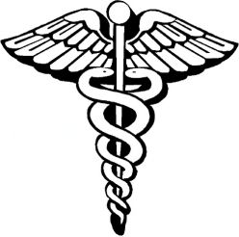
I have heard from many of these organisations that they feel that by being too thoroughly secular, their medical care has actually lost something. One agency’s atheist senior manager told me he thought they had lost the ‘voluntary’ factor – something essential about the care that can not be paid for. Agencies are once again appointing ‘chefs de mission’ and reframing some lost core values.

If Christianity is to be outlawed, why should the belief system of atheism be privileged instead. It too carries assumptions, history, values and views that are not compatible with many others in the wards, so why is it claimed to be more ‘objective’? We have a major philosophical blindspot in this discussion that needs to be brought into focus.In a western secular hospital system believers may feel silenced from speaking from a faith perspective.

However there are at least four more categories in which those contributions are vitally needed:
- In the politics of healthcare,
- in the science of medicine,
- in values of the work place,
- in reference to the gospel.

1.MAJOR POLITICAL RISKS TO THE HEALTHCARE SYSTEM

In political and managerial leadership, the magnificent legacy of Healthcare is at risk from budget measures driven by duplication and triplication of systems and the medical decisions of lawyers and actuaries. The sacred-secular tension needs a much larger debate than we can enter here. I want to focus in the time we have left upon some major risks to the healthcare system.

The biggest risk that I hear from medical practitioners is this: Under the weight of the ever-increasing power and cost of medical technologies, they wonder about their profession“Medicine has turned from healing to budgetting” The inherited safety net of healthcare may collapse under the weight of its cost and quality.

The Cost of healthcare is not just the cost of staff and pharmaceuticals:
- Triplication of health services – bulkbilled, insured, and ensured.
- Baby boomer bubble of population entering older age
- Commercial / government cost of tech and pharma
- People-intensive work, limits of automation
- Fear of litigation, cost of insurance
- The cost of post-graduate medical education is premised on high earnings for doctors.

The Quality of Healthcare is bracketed by:
- Budget-driven vs service motive. Who decides?
- Politically-driven priorities
- Profits and prestige not what it was

Partly the sophistication of costly medical technologies means that we cannot do everything that is technically possible for everybody who might benefit from it. The “triage” is done by the actuary in the health funds not by the practitioners.

Secondly, the rise of litigation, I believe, expresses the legitimate anxiety that “everything possible” will NOT be done for me. This in turn lowers the quality and raises the cost of tests and procedures that are performed mostly to protect the doctor’s backside from litigants! The implications go well beyond the doctor and patient relationship as the Spirit Level organisation (and other similar) have shown.
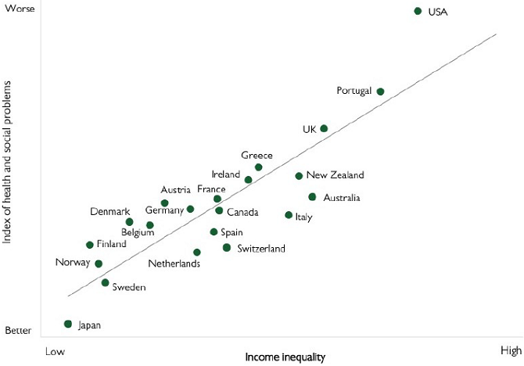
This graph is one of many showing the broader causes and outcomes of multiple stratified health systems.

SPIRIT LEVEL looked at multiple health indicators across all the contiguous United States as well internationally, using publically available statistics. They plotted them against inequality of incomes as one decent measure of social stratification, and found a consistent pattern as shown.

The factors used in the index show a heavy weighting towards health: Life expectancy of all persons, rates of maths and literacy, infant mortality, homicides, imprisonment, teenage births, measures of communal trust, obesity, illicit drug and alcohol addiction, vs social mobility measured as a positive. For example, where large inequalities exist, even the wealthiest have shorter average life expectancies. (Portugal’s figures are skewed by the inclusion of their colonies Angola and Mozambique.)

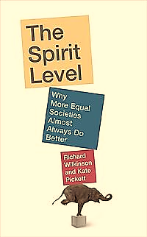
Their research started thirty years earlier with the rising cost of the British health system . They discovered, my paraphrase, that the social inequalities caused the multiplication of largely separate public and private health systems, which was more responsible for cost rises than the cost of treatments alone.

Current federal economic policy in Australia seems to emulate the country with the worst social outcomes (USA) though Oz is placed better than equivalent economies in UK and NZ. The highest gradient of inequality of pay rates is where a few high performers get paid a lot more and the rest get paid a lot less. Politicians identify with high performers and so they privilege them.

SPIRIT LEVEL argue strenuously that they are not right wing or left wing or religious in their conclusions, simply evidence-based. This argument claims that healthcare’s current risk factors play a major part in generating wider health and social risks. We can make a parallel argument with spiritual factors.

DISCUSS: The statistical argument now supports the values-based argument that was enjoined from decades ago – inequality if bad for us all. The Christian ‘global family’ ethos has from time to time been undermined by ‘cold-charity’ or by professionalism undermining the vocation to care. How would you see the Spirit-Level being restored?

2. CONTRIBUTION TO MEDICAL SCIENCE

A fracture line has emerged that simply must be healed between science and faith,. For this refer to the session on WXED science .
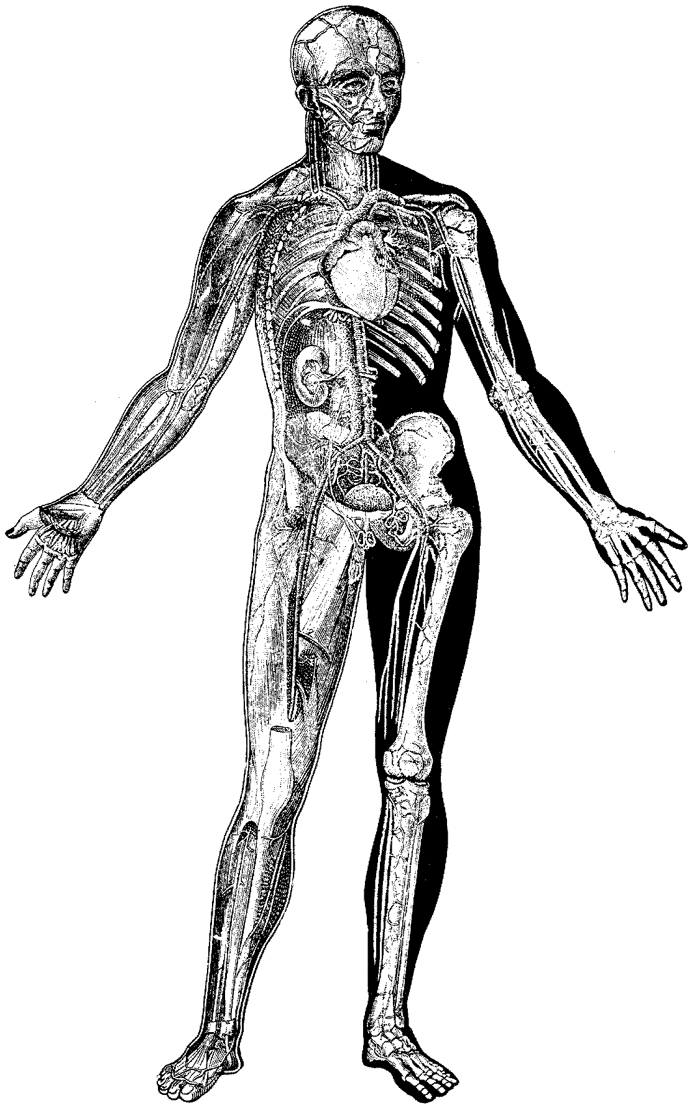
New decisions and responsibilities have been given to doctors by the ever-increasing power of medical technologies. The power to intervene has complicated many ‘end/beginning of life’ decisions and treatment options. The technology has left the populace way behind.

Ethical committees are working on these questions all over the world, amid great technological power and a rising anxiety about it as seen in anti-vaxxers, homeopathy, alternative remedies, creationists and paganism. How can we move forward? We don’t yet know what we think.

Fortunately, in addition to all the ethics committees in universities and hospitals and research institutes there are also many faith-and-science institutes. Here is a list of independent institutes that work on pulling together the application of the bible and practice of science, most of them including medical science, with integrity. If you google them you will find an Aladdin’s cave of both technical and overview topics. Christian healthcare is able to collaborate more effectively than ever before for the common good:
  - Faraday Institute
  - BioLogos Foundation
  - Reasons to Believe
  - Reasonable Faith
  - Institute for Study of Christianity And Science and Technology (ISCAST-Aust and UK)
  - Polkinghorne Trust
  - Pontifical Academy of Sciences

DIS CUSS:
Do you agree that ‘technology has left the populace way behind’?
What in your view are the pressing needs in the world for collaboration between the enterprises of science and the communities of faith?

3. CONTRIBUTION OF VALUES TO THE WORKPLACE

One great and widely acknowledged positive for the future is in the way Christians usually go about their work.

In performance of staff, Christian medical conferences have for decades taught many careful principles of ethical and loving service to colleagues and patients. It would not be wise , and it would reduce the joy in the work, to negate or mute these insights.

ISCAST, in their 2010 conference, focussed on the dilemnas of christians caught in “ethical scissor-grips”. The following values were named by the keynote speaker, Prof Gareth Jones, Otago University, formerly UWA, when he asked:
What can Christians contribute daily in their labs and wards and meetings?
He challenged all “medicos” to take up these ten affirmations as a kind of charter:

1. Swap Constrained giving for self-giving
2. Return to the importance of human flourishing and wholeness, ourself included (as healers).
3.Materialism and its bucket list: life is greater than death. Meaningful life is more than survival, more than suffering or death. Human life is not devoid of meaning simply because it is physically flawed: ‘In memory of Jesus and in hope ,the Christian community will delight in human flourishing, including the human flourishing we call “health”, but also be able to endure even the diminishing of human strength we call “sickness” with confidence in God’ Allen Verhey, Duke U.
4.Techniques should not become idols around which we create an alternative salvation-history
5. Protect the defenceless and disenfranchised from the powers & the ways of the corrupt.
6. Our ultimate dependence upon God and God’s work without us
7. Allow for the transformative power of the healing that Jesus brought and which can be experienced today
8. Remain grateful for medical achievements
9. Live with uncertainty and ambiguity
10. Love is a verb, and even when all else fails it is the overall guiding principle.

DISCUSS:
Is there any core value that you would add or subtract?
Which if any of these affirmations are on the “charter” that you work from already, stated or unstated?
Which might become a new area for growth for you? How will you gain exposure and insight to begin?

4. CONTRIBUTION THAT THE GOSPEL IS HEALING

The final positive contribution returns us to the core of the topic. The Gospel at the heart of the Christian faith, the centre pole of its tent is the word ‘Salvation’ ( in New Testament Greek sozo) . It can best be understood in terms of ‘healing’ – our own and the world’s – indeed the word sozo directly implies that. Some only think of heaven and hell after we die, but sozo talks about the change that is possible in this life. The attempt to describe “God with us” in terms of healing, then, goes back to the core of the gospels, getting a life before death.

Like antibiotics, in the light of the following diagnosis, I prescribe that we take a course in Jesus’ Love until it is completed...
  - Suffering is rife, mostly because humans refuse to care enough
  - We choose our responses – victim, compassion, denial, privilege, blame.
  - Jesus modelled compassion for all, as well as victory of love over death
  - Follow Jesus, because you can be healed enough to heal. His Spirit comes to you and through you to love your neighbour
  - ‘The tools of faith’ include prayer, Bible, science, systems, protest...

DISCUSS:
- What do you make of each of the statements above? Do you agree with the attempt to be creative in the way we imagine the gospel for today’s medical context?
- What would you add or subtract and why?
- In what ways do you observe that the gospel heals people or communities today?
- Can you write your own statement of gospel as healing?

CONCLUSION TO WXED Healthcare?

The short summary of this talk is this –

- if you expect that if you get sick someone will help you, no matter who you are, you probably need to be thankful to Jesus Christ and his followers who have created that culture. I have argued a case for universal care and widespread genius in the garden ground floor of healthcare. I have also shown that Christianity has a particular role in the history of healing by providing the impetus and model - the stairs to the rooms on the top floor. Today, if you get sick, the common sense within this culture arising from its Christian heritage says you will be treated.

- Change that culture if you wish, but understand what it is, and do not expect that your need or your humanity will be respected as a matter of reason or common sense.

- Instead, build the cultural capital that the church has granted generously to the world in the name of Jesus Christ. The church has been an hospitable community of Christ, spreading the hope and compassion of Christ, living up to their high calling in Christ and acting collaboratively in the Name of Christ. In the light (if that’s the word) of the three specific corrupt behaviours that have arisen within the track record for sustained, widespread and positive line of action for the common good, the authority of Christian workers should always be conditional and accountable in any organisation.

- I hope you now have grounds for a fresh consideration of this culture as you reflect on your own resources and reasons to be in the healing house. If you are a health practitioner, thank you for what you do.

May I leave you all with this blessing, my one quiet moment of practical theism in this entire academic-oriented study. Let it pass or to accept it freely, it is up to you.

Whether you know it or not,
whether you like it or not,
you are a gift of God to the world.
May you be a nuisance
to all closed minds and closed hearts,
respecting all persons.
May beauty, truth and goodness
flow into the world
from your faith, hope and love.
May the God of all wisdom
guide your path,
shine hope into your struggle
and heal your love.
Do not fear, it is enough to say ‘yes’.
WXED HEALTHCARE

Do you expect that if you get sick someone will help you, no matter who you are in the social scale? You probably need to be thankful to Jesus Christ and his followers who have created that culture. It is not that way everywhere in the world. Change that culture if you wish, but understand what it is, and do not expect that your need or your humanity will be respected as a matter of reason or common sense.

This is one a series of small group discussion books on “What’s Christianity Ever Done?” We have researched science, education, law, arts and healthcare. Each study looks backwards across the cultural impact of Christianity and describes -
- how the principles of faith have undergirded that discipline,
- how persons of faith have been pioneers and creators of that discipline,
- how the church has sometimes corrupted their role and
- how there might be potential need for collaboration into the future.

